From Four Giants, to Two Giants

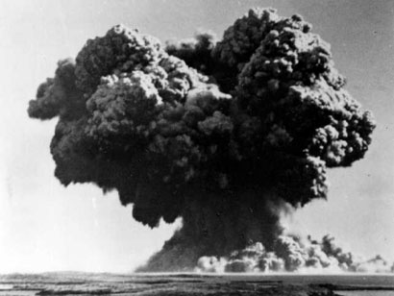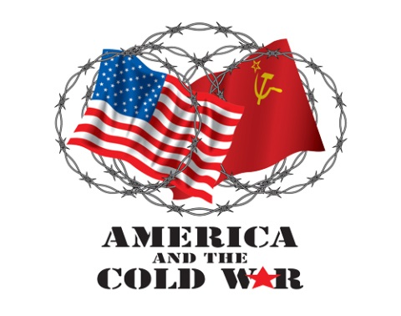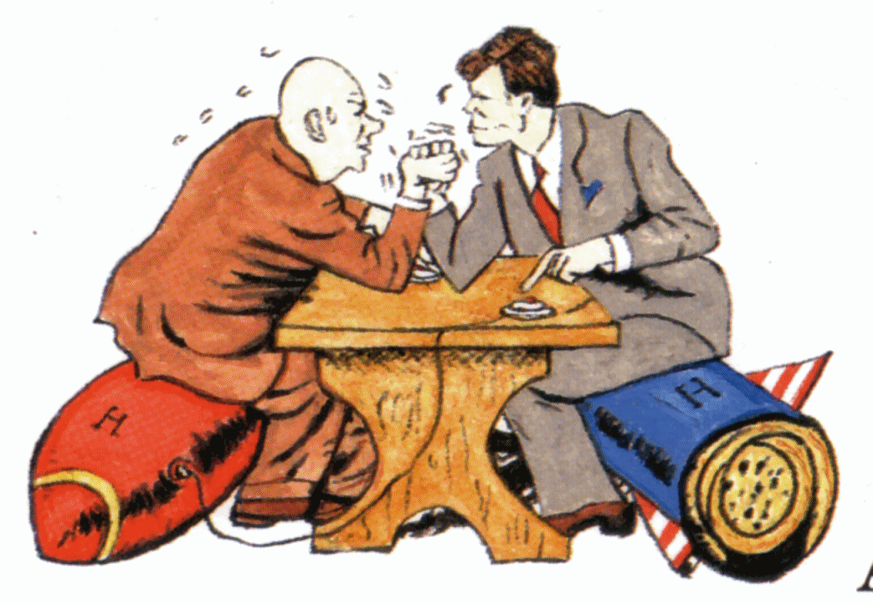

|  |  |  |
| --- | --- | --- |
| Area of interaction focus Which area of interaction will be our focus? Why have we chosen this? |  | Significant concept(s) What are the big ideas? What do we want our students to retain for years into the future? |
| Human Ingenuity  Awareness and understanding of the bi-polar world and how individuals created systems of security that changed the course of history  Reflection on the positive and negative impact of the nuclear age, on mutual security and on everyday life of aligned and non-aligned nations | The search for security does not always lead to security for all. |

**[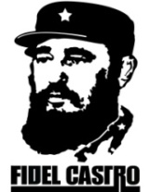](http://imagehost.vendio.com/a/35104282/aview/fidelcastro.jpg)** 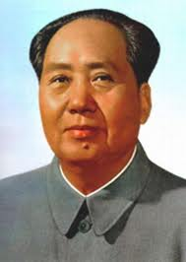

|  |
| --- |
| MYP unit question |
| How can I look after myself and others? |

**[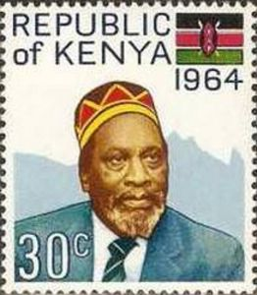](http://i.colnect.net/images/f/753/958/Jomo-Kenyatta.jpg)**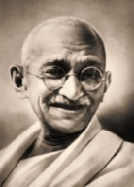

**Approaches to Learning:**

* **Thinking Critically**: applying knowledge and concepts, generating ideas, inquiring, questioning, developing questions
* **Communication**: interpreting content and terminology, being informed, informing others

**Summative Assessment:**

[Students will]

1. Keep an organized interactive **Notebook** – Unit 5 materials

2. Research and create two **trading cards** on a leader of 2 nations – 1 Capitalist/1 Communist

3. Engage in a **debate** about the effectiveness of different systems of safety and security in the Cold War world

4. Develop a 750-1000 word **essay**

* Students will show an understanding of the bi-polar world and describe how individuals created systems of security or responded to threats to their security.
* Students will discuss at least 2 leaders or individuals who changed the society in which they lived and discuss the impact on their societies.
* Students will provide a reflection on the positive and negative impact of the nuclear age, on mutual security and on everyday life of aligned and non-aligned nations.

Humanities Objectives: Thinking Critically and Communicating

Humanities Criteria: Thinking Critically and Communicating

**Learning Experiences:**

**Readings of:** Cold War, Strategies of the Cold War, Communist China, War in Korea, War in Vietnam, Détente, Independence in India, SE Asia and Africa, Conflicts in the Middle East, The Struggle for Democracy

**Interpretation of cartoons and propaganda posters**: Cold War, The Iron Curtain, Independence Movements

**Reading of Maps**: Cold War Enemies, War in Korea, War in Vietnam, Cold War Hot Spots, African Independence Movements

**Analysis of Primary Sources**: Winston Churchill, Mao Zedong, Fidel Castro, Nikita Khrushchev, Jawaharlal Nehru, Nelson Mandela, Gandhi

**Answering Essential Questions/interactive power point/note taking**: Cold War, Communist China, War in Korea, War in Vietnam

**Video Clip interpretation:** Cold War, Communist China, The Killing Fields, Vietnam War

**Debates:**

* Argue differences between communism and capitalism; Why two nations of the world had to choose a side after WWII to keep each other “safe and secure”; How communist/totalitarian nations developed ways to ensure the safety and security of their citizens.
* Argue the positive and negative impact of these; How Capitalist/Democratic nations developed ways to ensure the safety and security of their citizens. Debate the positive and negative impact of these.

**Topic Outline:**

**Post-war world:**

1. Human and physical geography

2. The world in 1945 United States occupation of Germany and Japan

a. The adoption of democratic systems of government

b. Economic rebuilding of Germany and Japan

4. Emergence of the superpowers

5. Political climate of the Cold War

A. Marshall Plan

B. Truman Doctrine

c. Berlin airlift and a divided Germany

d. North Atlantic Treaty Organization (NATO)/Warsaw Pact

**—**expanding membership and role of NATO

**Role of the United Nations**

1. Peace keeping

2. Social and economic programs

**Ideology in the Cold War and Post-Cold War era**

1. Comparison of market and command economies (Western Europe versus Soviet Union)

**Triumph of communism in China - Chinese communist revolution**

1. Human and physical geography

2. Communist rise to power (1936-1949); ,Jiang Jieshi (ChiangKai-shek), Mao Zedong

3. Communism under Mao Zedong

a. Great Leap Forward

b. The Cultural Revolution and the Red Guard

**“To be, or not to be aligned”: Collapse of European imperialism in India and Vietnam**

1. Human and physical geography

2. India—independence and partition

3. Vietnam War

4. African independence movements and Pan Africanism

**Unit 5 Rubric for Formative and Summative Assessments**

**Criterion C: Thinking Critically**

|  |  |  |  |
| --- | --- | --- | --- |
| **Achievement Level** | **Level Descriptor** |  | **Indicators (evidence that student achieved this level)** |
| **7-8**  **Regents 5** | The student:  • completes a **detailed** analysis of concepts, events, issues, models or arguments  • **thoroughly interprets a range of** different perspectives and their Implications  • synthesizes information to make **valid, well-supported** arguments.  Thoroughly **develops all** aspects of the task evenly and in depth. Is more analytical than descriptive (analyzes, evaluates, and/or creates information). Richly supports the theme with many relevant facts, examples, and details Demonstrates a logical and clear plan of organization; includes an introduction and a conclusion that are beyond a restatement of the theme. | **Description** of two 2oth century leaders and their impact history  **Discuss** the impact of the nuclear age on the safety and mutual security of aligned and non-aligned nations  **Evaluates** the positive and negative effect two different ideologies of the Cold War in different parts of the world.  **Explain** how the search for security does not always lead to security for all |

**Criterion D: Communication**

|  |  |  |  |
| --- | --- | --- | --- |
| **Achievement Level** | **Level Descriptor** |  | **Indicators (evidence that student achieved this level)** |
| **7-8**  **Regents 5** | The student:   * Communicates information and ideas using an appropriate style for the audience and purpose. * Organized information and ideas in a way that is appropriate to the specified format. * Creates a list of sources of information that follows the task instructions. | * Student communicated information in a way that is clear to the intended audience. * Student organized information completely in the order needed for the task. * Student created an accurate list of sources of information that followed the task instructions * Student communication includes the use of evidence to support each topic sentence |